## Western Australian Certificate of Education

**Semester 1 Examination, 2016**

##### Question/Answer Booklet

**COMPUTER**

**SCIENCE**

**Unit 1: Year 11 ATAR**

|  |  |  |  |  |  |  |  |  |  |  |
| --- | --- | --- | --- | --- | --- | --- | --- | --- | --- | --- |
| Student Number: In figures |  |  |  |  |  |  |  |  |  |  |

In words

**Time allowed for this paper**

Reading time before commencing work: ten minutes

Working time for paper: two hours 30 minutes

**Materials required/recommended for this paper**

***To be provided by the supervisor***

This Question/Answer Booklet

Multiple Choice answer sheet

###### *To be provided by the candidate*

Standard items: pens, pencils, eraser, correction fluid/tape, ruler, highlighters

Special items: non-programmable calculators, MATHOMAT and/or Mathaid and/or any system flowchart template

**Important note to candidates**

No other items may be taken into the examination room. It is **your** responsibility to ensure that you do not have any unauthorised notes or other items of a non-personal nature in the examination room. If you have any unauthorised material with you, hand it to the supervisor **before** reading any further.

**Structure of this paper**

|  |  |  |  |  |  |
| --- | --- | --- | --- | --- | --- |
| Section | Number of questions available | Number of questions to be answered | Suggested working time (minutes) | Marks available | Percentage of exam |
| Section Two:  Short answer | 20 | 20 | 75 | 55 | 40 |
| Section Three:  Extended answer | 3 | 3 | 75 | 77 | 60 |
|  |  |  |  | **Total** | 100 |

**Instructions to candidates**

1. The rules for the conduct of Western Australian external examinations are detailed in the *Year 12 Information Handbook 2016*. Sitting this examination implies that you agree to abide by these rules.

2. Write your answers in the spaces provided in this Question/Answer Booklet. A blue or black ballpoint or ink pen should be used. Wherever appropriate, fully labelled diagrams, tables and examples should be used to illustrate and support your answers.

3. You must be careful to confine your responses to the specific questions asked and to follow any instructions that are specific to a particular question. Where no specific instructions are given, you should feel free to use a range of formats to express your knowledge and understandings.

4. Spare pages are included at the end of this booklet. They can be used for planning your responses and/or as additional space if required to continue an answer.

* Planning: If you use the spare pages for planning, indicate this clearly at the top of the page.
  + Continuing an answer: If you need to use the space to continue an answer, indicate in the original answer space where the answer is continued, i.e. give the page number. Fill in the number of the question(s) that you are continuing to answer at the top of the page.

**Section One: Short answer** **40% (55 Marks)**

This section contains **20** questions. You must answer **all** questions. Write your answers in the spaces provided.

Spare pages are included at the end of this booklet. They can be used for planning your responses and/or as additional space if required to continue an answer.

* + Planning: If you use the spare pages for planning, indicate this clearly at the top of the page.
  + Continuing an answer: If you need to use the space to continue an answer, indicate in the original answer space where the answer is continued, i.e. give the page number. Fill in the number of the question(s) that you are continuing to answer at the top of the page.

Suggested working time: 75 minutes.

**Question 1 (2 marks)**

Explain, using an example, the difference between The System Development Life Cycle and Prototyping.

|  |  |
| --- | --- |
| Use of Example (1 mark) and accurate description | 2 marks |
| Accurate description no example | 1 mark |
| Possible answers  SDLC more methodical goes through stages an is linear. Prototyping non-linear and rapidly develops a solution that is then adjusted |  |

**Question 2 (3 marks)**

Your computer fails to recognise the USB you have plugged into a USB port. Identify three trouble shooting strategies you could use in this situation.

|  |  |
| --- | --- |
| Accurately identifies 3 troubleshooting strategies | 3 marks |
| Accurately identifies 2 troubleshooting strategies | 2 marks |
| Accurately identifies 1 troubleshooting strategy | 1 mark |
| Possible answers: Try another usb to see if it is port. Put usb in another machine to see if it is usb, check to see if drivers up to date, install updated drives, check to see if antivirus blocking – any reasonable |  |

**Question 3 (3 marks)**

1. Identify the purpose of an ICT Code of Conduct. (1 mark)

Voluntary set of rules within a workplace to establish minimum behaviour expectations around the use of ICT

1. Identify and justify the inclusion of two items into an ICT Code of Conduct written specifically for teachers within a secondary schooling environment. (2 marks)

|  |  |
| --- | --- |
| Accurately identifies **and justifies** 2 items | 2 marks |
| Accurately identifies **and justifies** 1 item | 1 mark |
| No justification | 0 |
| Possible answers: do not supply password and username to someone else: so that accurate audit trails are established and able to track malicious use. So person does not get blamed for something they did not do  Don’t use School resources to download movies etc: minimise bandwidth use and make sure there is enough for business practises, also minimise copyright/piracy issues.  Do not take confidential data files home on USB: to prevent someone getting hold of confidential student files, ie protect legal obligation to privacy for both staff and students  *Any reasonable answer with justifications.* |  |

**Question 4 (4 marks)**

Explain how the fetch-execute cycle interacts with a system’s RAM, system clock, control unit and registers.

|  |  |
| --- | --- |
| Accurately identifies FETCH (from RAM into cache/registers) (1 mark) DECODE (control unit) (1 mark); EXECUTE (ALU) (1 mark); STORE (registers) (1 mark)  System clock synchronises each cycle  *With appropriate explanations* | 4 marks |

**Question 5 (3 marks)**

Explain the difference between a solid state drive and a mechanical disk detailing why you would use one over the other.

|  |  |
| --- | --- |
| Accurately describes difference with reference to characteristics of both. Details why one would be used over the other (mechanical over ssd and ssd over mechanical) | 2 marks |
| May describe difference by referring to characteristics of both but not go into explanation of why one being used over the other | 1 mark |
| May describe difference of one and use that difference to explain why one over the other | 1 mark |
| may describe difference or state one better than the other with reason | 0 mark |
| Possible answers:  A mechanical disc uses mechanical platters which are written to by a mechanical arm. An SSD uses a series of flash memory chips. SSD’s are faster but mechanical drives are cheaper so choosing on over the other comes down to price v speed. |  |

**Question 6 (3 marks)**

Documentation including Context and Data Flow Diagrams are part of the Systems Development Life Cycle. Explain why this is so and in which stage(s) of the SDLC they are generally developed.

|  |  |
| --- | --- |
| Accurately identifies **and explains** Context and Systems are part of both design and analysis | 3 marks |
| Accurately identifies **and explains** why they are used in one f the stages | 2 marks |
| Identifies one stage | 1 |
| Possible answers: used in both analysis and design phases. In the analysis phase a developer would want to develop an understanding of the system boundaries and how the data flows through the current system. In the design phase a developer may find that they need to change in the new system that conforms to client requirements as outlined in the preliminary analysis. |  |

**Question 7 (1 mark)**

What is the difference between a Data Flow Diagram and a Context Diagram?

|  |  |
| --- | --- |
| One identifies the boundaries of a system, the other identifies the data and how it flows through the system | 2 marks |
| Describes only one side | 1 mark |
|  | 0 |

**Question 8 (3 marks)**

Describe the function of each of the following buses within a system unit:

|  |  |
| --- | --- |
| Accurately explains the function of the three buses | 3 marks |
| Accurately explains the function of two buses | 2 marks |
| Accurately explains the function of one bus | 1 mark |
| Possible answers:  Data bus: moves the data from the RAM to the control unit  Address bus: stores the address of where the data is located.  *Control bus:allows communication between the CPU and other devices* |  |

**Question 9 (2 marks)**

A user wants to detect and clean a virus-infected file as it is opened. Explain how would this be achieved?

|  |  |
| --- | --- |
| It would be preferable not to open a virus infected file by scanning it beforehand – email etiquette. However by using an up to date anti virus. Switch it on in the background or run a scan individiually. If the software comes back with an alert, isolate and open it in a safer mode or delete it as needed. | 2 marks |
| Mentions anti-virus with no explanation | 1 mark |

**Question 10 (1 mark)**

Identify a technique used to minimise damage caused by electrostatic discharge.

Using an anti-static wrist band, tap any metal out before placing it inside the case.

**Question 11 (3 marks)**

Identify three data characteristics that a Data Dictionary will identify for a Database Management System.

|  |  |
| --- | --- |
| Accurately identifies **3** | 3 marks |
| Accurately identifies **2** | 2 mark |
| Accurately identifies **1** | 1 mark |
| Possible answers:  Identifies the data type to be held in a field  Identifies how many characters will be held in a fields cell  Identifies any validity checks enabled or enforced  Identifies whether the field is a primary key  *.* |  |

Characteristic 1:

Characteristic 2:

Characteristic 3:

**Question 12 (3 marks)**

Identify three advantages of implementing a Relational Database Management System.

Advantage 1:

Advantage 2:

Advantage 3:

|  |  |
| --- | --- |
| Accurately identifies **3** | 3 marks |
| Accurately identifies **2** | 2 mark |
| Accurately identifies **1** | 1 mark |
| Possible answers:  Greater control over who accesses data via administrator control features in the RDBMS software  Greater control over how the data is entered via a GUI or switchboard, enforcement of data validation procedures  Greater ability to save a backup to be stored offsite if centralised RDBMS  If properly designed – less redundancy and greater integrity  *.* |  |

**Question 13 (4 marks)**

Identify and explain four troubleshooting strategies that could be used to ensure the hardware is run optimally.

|  |  |
| --- | --- |
| Accurately identifies **and explains** 4 | 4 marks |
| Accurately identifies **and explains** 3 | 3 marks |
| Accurately identifies **and explains 2 or lists 4** | 2 marks |
| Accurately identifies **and explains** 1 or lists 2 | 1 marks |
| Possible answers:  Defrags  Backups  Check cables  Clean with compressed air  Keep in temperature controlled environment  Turn off when not in use  *.* |  |

**Question 14 (2 marks)**

Identify and explain two (2) tools a project manager could use to monitor and track the progress of a system development project.

|  |  |
| --- | --- |
| Accurately identifies **and explains 2** | 2 marks |
| Accurately identifies and explains 1 | 1 marks |
| Accurately identifies **1** | 0 |
| Possible answers:  A Gantt chart could help the project manager monitor the sequencing and timing of the tasks to ensure the remain on track to finish in time.  A budget tracking spreadsheet could help the manager ensure the project stays within the stipulated budget – use of a spreadsheet.  Project management software could also help here as they provjde the ability to coordinate tasks amongst multiple personnel  *.* |  |

**Question 15 (4 marks)**

Describe four data gathering techniques that can be used within the SDLC and at which stage they are likely to be used and why.

Technique 1:

Stage:

Why:

Technique 2:

Stage:

Why:

Technique 3:

Stage:

Why:

Technique 4:

Stage:

Why:

|  |  |
| --- | --- |
| Accurately identifies 4 data gathering techniques and the stage and why they would be used | 4 marks |
| Accurately identifies **3** data gathering techniques and the stage and why they would be used | 3 marks |
| Accurately identifies **2** data gathering techniques and the stage and why they would be used | 2 mark |
| Accurately identifies **1** data gathering techniques and the stage and why they would be used | 1 mark |
| Possible answers:  Work shadowing: in the data analysis stage to ascertain how the date is used by the users  Document analysis: can be used also in the analysis stage to determine how the date is collected, formatted and used in the organisation  Surveys can be used in the analysis, the design, implementation and maintenance stages to establish how data is used, what the clients want it to look like, check to see if implementation is working and then check how successfully the new design is meeting client requirements  Interviews can be used as a face to face verification in analysis of data as well as checking the Design and how well it works in Maintenance  *.* |  |

**Question 16 (4 marks)**

Identify four (4) errors with the following context diagram.

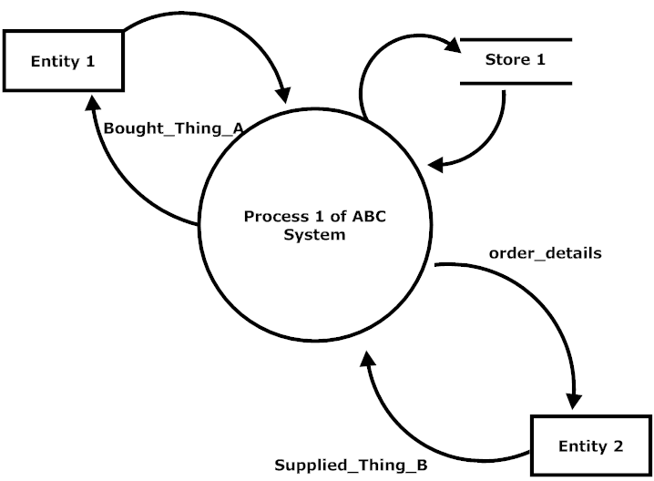

|  |  |
| --- | --- |
| Data stores in context | 1 mark |
| Thing being transferred not data | 1 mark |
| Name of system- process | 1 mark |
| Unlabelled data flows | 1 mark |

**Question 17 (3 marks)**

1. Explain the purpose of an Entity Relationship Diagram. (1 mark)

It establishes **the relationship between the entities** and you would use it to help design a rdbms (relationship between entities important)

1. Where is it likely to be developed within the System Development Life Cycle? Justify your answer. (2 marks)

|  |  |
| --- | --- |
| Identify stage – design/analysis | 1 mark |
| With justification - | 1 mark |
| Analysis – to analyse the current system  Design – to establish the top down set up of the future system |  |
|  |  |

*Questions 18 – 20**relate to the following information*

Damian owns a small lunch bar in the City. Damian sells many food items but a supplier can only supply one food item. Each supplier has a supplier number and Damian needs their address and phone number stored in the database. Each food item also has an item number and a menu item description (eg, hot, cold, drinks, confectionary etc).

**Question 18 (6 marks)**

Draw the ERD to reflect the current business rules for Damian’s business indicating primary keys, foreign keys and relevant attributes.

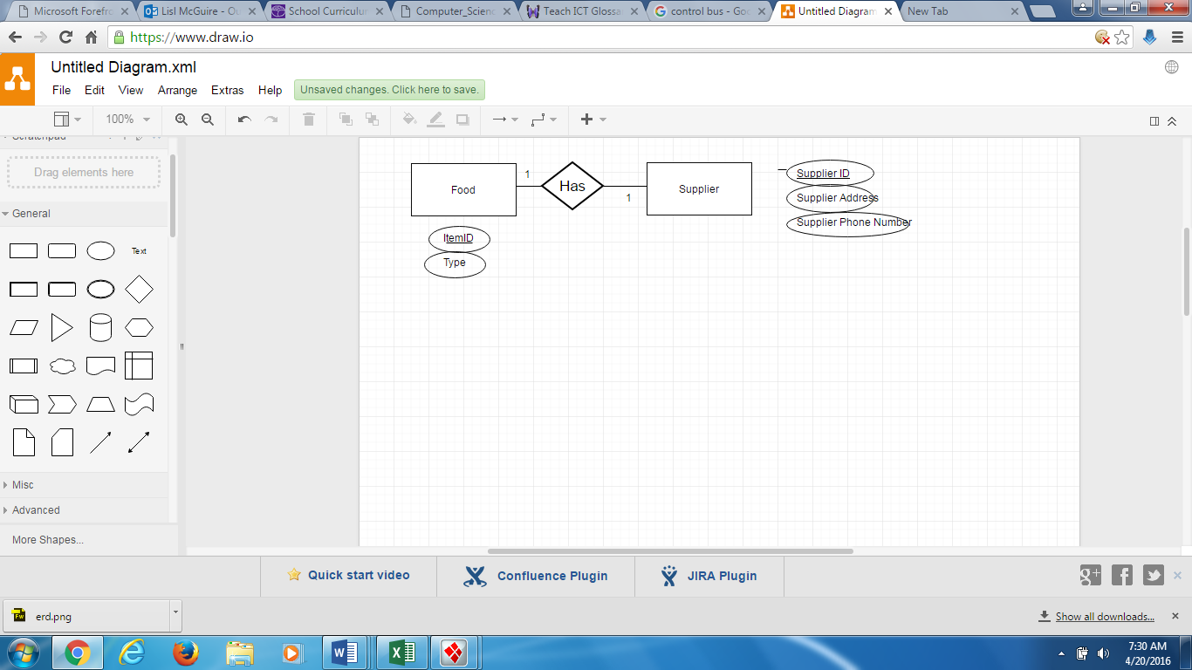

**Question 19 (1 mark)**

The business rules have changed. Damian can now buy many food items from a supplier. Describe how this will change the ERD that you have drawn in Question 18.

|  |  |
| --- | --- |
| it will create a many to many relationship between food and supplier/ | 1 mark |
| This will need to be resolved with an associative entity | 1 mark |

**Question 20 (1 mark)**

Damian has been told he needs a ‘Date Purchased’ attribute and he has been advised to use a mask. Why would he have been advised to do this and how will this impact the data?

|  |  |
| --- | --- |
| He would have been advised to do this to restrict what a user can input. | 1 mark |
| improve the validity of data. | 1 mark |

**End of Section One**

**Section Two: Extended answer 60% (77 Marks)**

This section contains **three (3)** questions. You must answer **all** questions. Write your answers in the spaces provided.

Spare pages are included at the end of this booklet. They can be used for planning your responses and/or as additional space if required to continue an answer.

* + Planning: If you use the spare pages for planning, indicate this clearly at the top of the page.
  + Continuing an answer: If you need to use the space to continue an answer, indicate in the original answer space where the answer is continued, i.e. give the page number. Fill in the number of the question(s) that you are continuing to answer at the top of the page.

Suggested working time: 75 minutes.

Refer to source sheet

Question 21 refers to Figure A: Page 1 of the Source Sheet.

**Question 21 (15 marks)**

1. There are only four (4) types of employment status. What tool could you use in column E2 onwards to make data input more efficient? (1 mark)

A drop down list

1. ABC Pty Ltd wish to apply a pay raise of 2.91% to everyone’s salary. What formula would you use to do this? (include all absolute and relative cell references). (3 marks)

|  |  |
| --- | --- |
| Absolute reference on $M$1 M$1 would also be correct – need to change cell to 1.291 or I2 x $M$1 = I2 | 1 mark |
| Multiplication on column I x M1 | 1 mark |
| Contained in column k | 1 mark |
| Answer -  In Cell K1 = I2 +($M$1 x I2) |  |

1. What action would you take to ensure this is applied to all employees listed in this spreadsheet efficiently? (1 mark)

Copy down Cntrol D

1. ABC Pty Ltd wish to calculate the average salary paid to its Full-Time employees. What combination of functions could be used to do this? (3 marks).

If (say E2 = Fulltime) , Total, Count Tot/count or Ave If

Students do not need to list the actual cell formula just the functions they could use.

1. Employees tax is calculated according to the scale in range N2:P8. At $25,000 a person would have paid $6,300 in tax. This calculated as follows

($25,000 - $5000) x 21% = $6,300

A person earning $26,000 would have paid

$6,300 + ((26000-25000)x 25%) = $6,550

1. What sort of formula would be suitable to calculate tax in column K? (1 mark)

V lookup

1. Write the formula to be used in column K. (6 marks)

In column

=((K2-(VLOOKUP(K2,$N$2:$P$8,1))))*(VLOOKUP(K2,$N$2:$P$8,2))+(VLOOKUP(K2, $N$2:$P$8,3)) will also accept if they use column I

|  |
| --- |
| ( K2 – 25000 x 25%) (4 marks) + 6,300 (2 marks) |
| =((K2-(VLOOKUP(K2,$N$2:$P$8,1))))*(VLOOKUP(K2,$N$2:$P$8,2))+(VLOOKUP(K2, $N$2:$P$8,3)) |

**Question 22 (21 marks)**

This question refers to Source B on page 1 of the Source sheet.

1. ABC Pty Ltd have been advised to create a relational database to store employee data instead of the current spreadsheet. Fixem have advised that this new relational database can also be accessed over the internet.
2. What are two benefits of using a relational database over a spreadsheet?

(2 marks)

|  |  |
| --- | --- |
| Reduces redundancy | 1 mark |
| Can improve security | 1 mark |
| Can improve input validity and therefore integrity | 1 mark |
| Can create queries and reports on the data | 1 mark |

1. Explain one disadvantage of creating a relational database instead of continuing to use the spreadsheet? (2 marks)

|  |  |
| --- | --- |
| Disadvantage | 1 mark |
| explanation | 1 mark |
| Possible answers:  RDBMS requires greater knowledge and generally a dedicated person do develop and run it – more expensive  RDBMS – may be at greater risk if it is online and not secured fully  RDBMS may cost more when you want to extract queries and reports that are not standard |  |

1. Identify two ethical issues potentially associated with establishing a relational database system that can also be accessed online. (2 marks)

|  |  |
| --- | --- |
| Issue 1 | 1 mark |
| Issue 2 | 1 mark |
| Possible answers  Privacy of sensitive personal information if someone hacks online  If it is only accessible online- what happens if server goes down – sensitive data lost  What can be viewed by whom in terms of privacy and access to the data – privacy act | |

1. Identify an issue with the following Entity Relationship Diagram according to the business rules contained in Source B. (2 marks)

|  |  |
| --- | --- |
| Many to many | 1 mark |
| That needs to be resolved | 1 mark |
|  | |

**Employee**

**M**

**Location**

**Department**

**has**

**1**

**M**

**contains/**

**is contained**

**M**

1. Redraw the Entity Relationship Diagram below resolving the issue identified in (b) and listing only primary and foreign keys for each entity. (13 marks)

**Employee**

**M**

**has**

**1**

**1**

**1**

**Department**

**has**

**has**

**Department/location**

**Location**

**M**

**M**

|  |  |
| --- | --- |
| Associative entity | 1 mark |
| Plus PK FK and ass entity | 2 marks |
| Relationships | 3 marks |
| Cardinality correct | 3 mark |
| Foreign key in employee | 1 mark |
| Primary key employee | 1 mark |
| Chens | 2 marks |

**Question 23 (41 marks)**

This question refers to Source C, page 2 of the Source Booklet.

1. Fixem have advised that they will undertake a System Development Life Cycle (SDLC) approach rather than a prototype approach. Explain why the SDLC approach may be suitable in this situation. (3 marks)

|  |  |
| --- | --- |
| Cost may be an issue – so budgetary pressures | 1 mark |
| Accuracy due to personal nature and external reporting to tax office | 1 mark |
| Owner does not seem to know what they are doing so better suited to SDLC | 1 mark |
| No indication of fast development required | 1 mark |
| There is a legal framework to be adhered to due to personal/privacy issues | 1 mark |

1. Identify two types of systems development documentation and state in which part of the Systems Development Life Cycle they will developed. (4 marks)

|  |  |
| --- | --- |
| Feasibility study – preliminary analysis | 2 marks |
| DFD/Context – analysis or design phase | 2 marks |
| GANTT chart – preliminary analysis or justifies some other sage | 2 marks |
| Troubleshooting guide – evaluation and maintenance | 2 marks |
| Requirements analysis – preliminary analysis | 2 marks |
| Any two of the above or other reasonable | |

1. Complete the context diagram for the new ABC Human Resource Management System below. You may create more entity shapes as required. (14 marks)

**Advertise**r

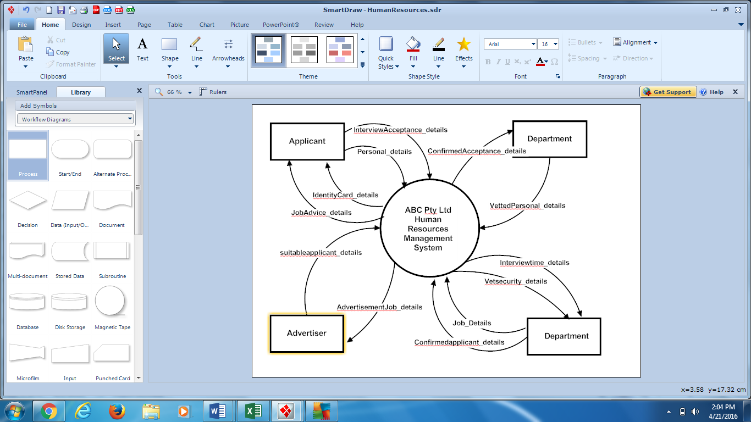

|  |  |
| --- | --- |
| Entities | 3 marks |
| System name correct | 1 mark |
| Data flows in correct format _details | 10 marks |
|  |  |
|  |  |

1. 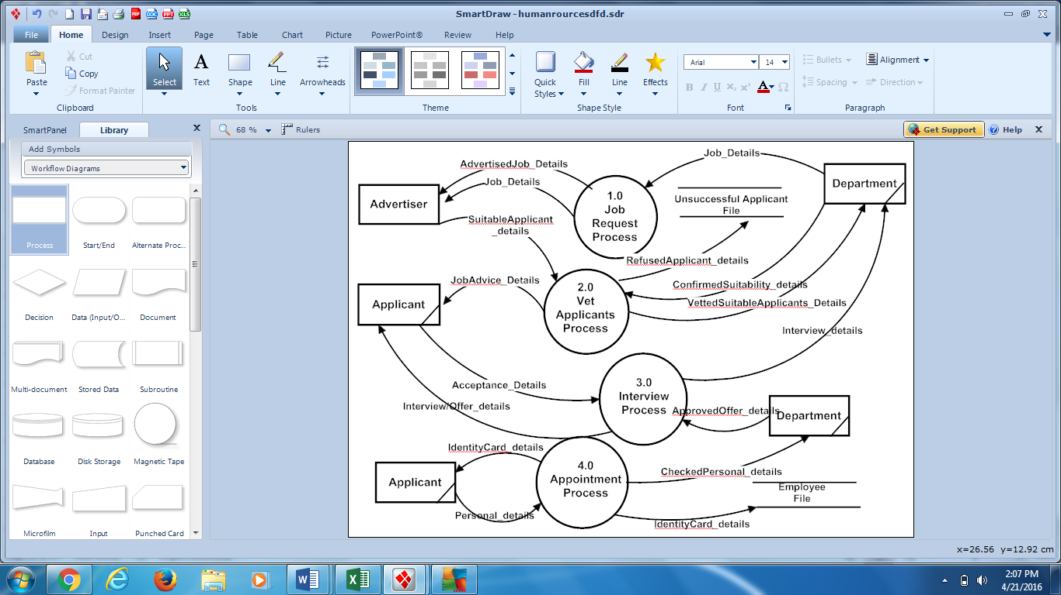Create a level 0 DFD using the following outline below (20 marks)

|  |  |
| --- | --- |
| Processes identified and correctly labelled | 1-4 marks |
| Files correctly formatted | 1-2 marks |
| Entities correctly formatted | 1-3 marks |
| Data flows marry to context and ***show processing*** as well as being correctly formatted | 1-8 marks |
| All external flows marry up to context | 3 marks |
|  |  |
|  |  |

**End of Examination Questions**

Additional working space

Question Number:___________

Additional working space

Question Number:___________

Additional working space

Question Number:___________